Please follow the steps below to replicate my tutorial for Windows. For Linux, please refer to the video recording.

1. Install environment
   1. Go to [MySQL :: Download MySQL Installer](https://dev.mysql.com/downloads/installer/) and download and install MySQL.
   2. Once installed, open MySQL command line client.

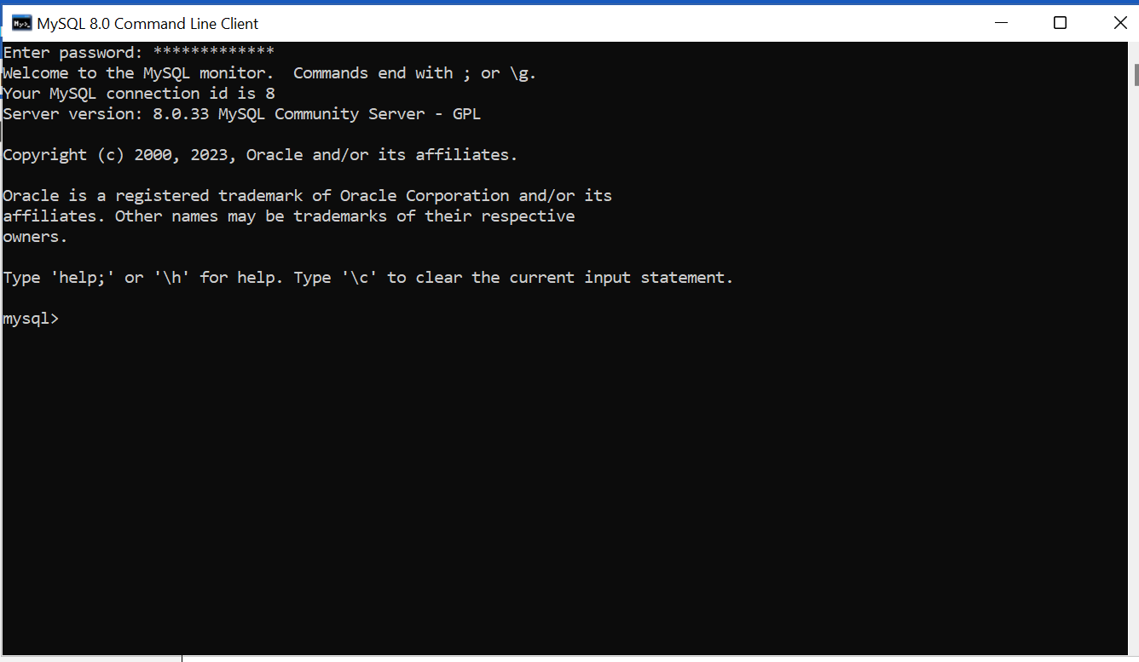

* 1. Create a database.



* 1. Create a table.

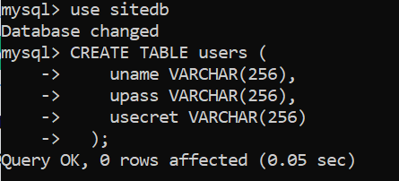

* 1. Let’s proceed to the python program to build our web app.

1. Download and install python from [Download Python | Python.org](https://www.python.org/downloads/)
   1. Install Python. Ensure you add Python to the Path variable and customize installation as per the screenshot below.

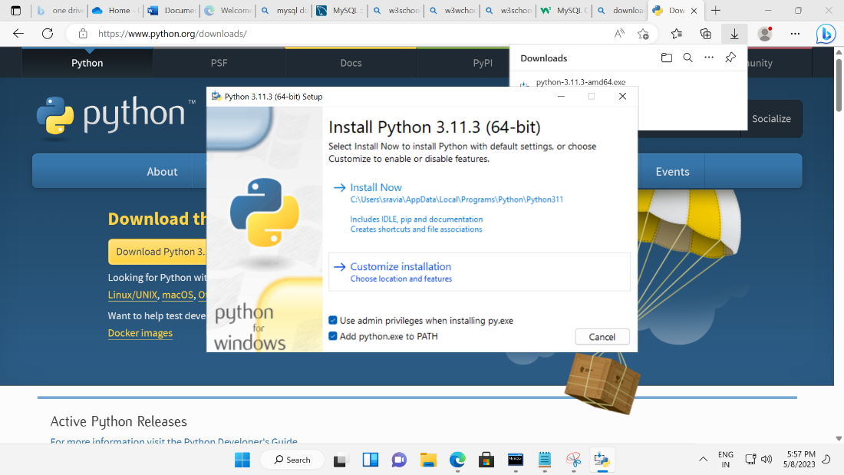

* 1. Install Python for all users as per the screenshot below

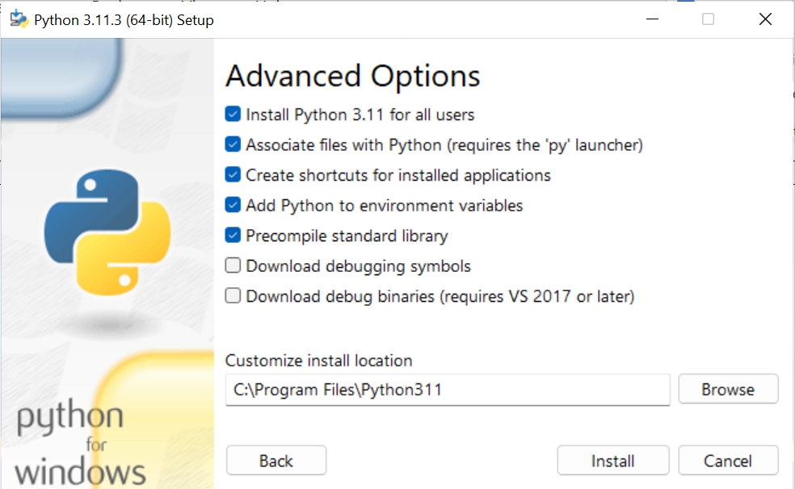

* 1. Disable path length limit as per the screenshot below
  2. 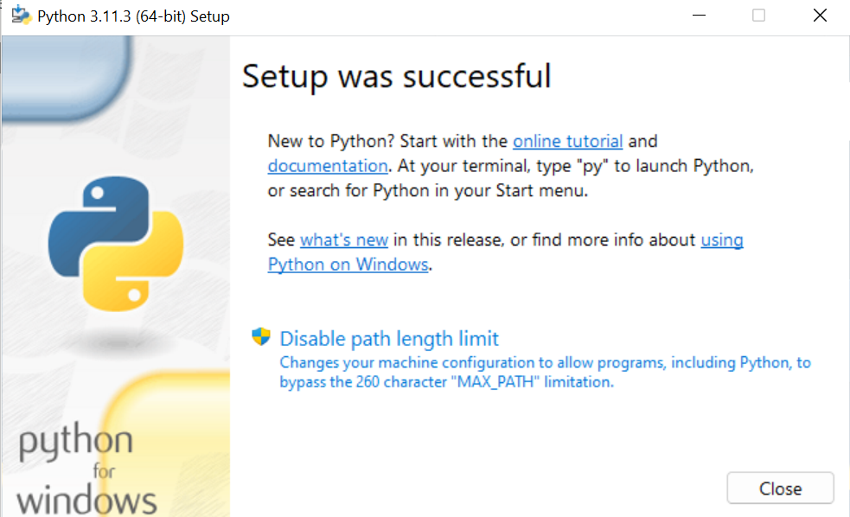

1. Open command prompt (cmd.exe) and check that Python has successfully installed
   1. 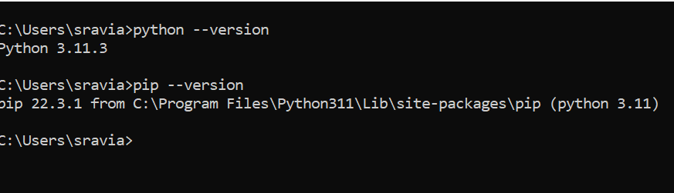
2. Now let’s ensure we have a virtual environment where we only install the modules we need.
   1. 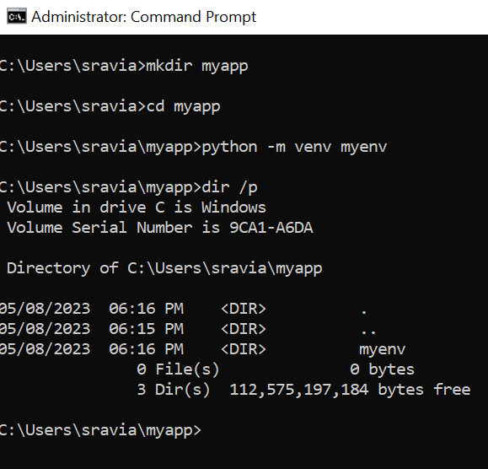
   2. Activate the virtual environment you just created
   3. 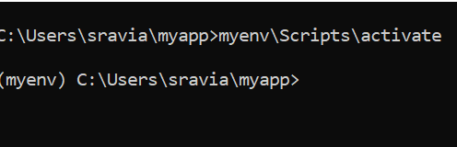
   4. Do you observe a (myenv) before the command prompt? That shows our virtual environment has started.
3. Now we will install the modules we need.
   1. 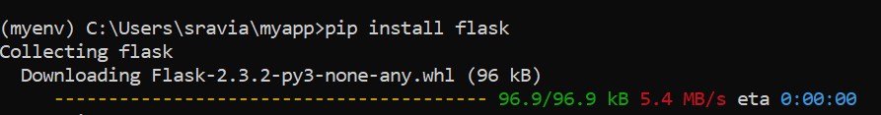
   2. 
   3. We need flask to build a web server and mysql-connector-python to connect to our database.
4. Install git and GitHub.
5. Now ‘git clone’ my project from <https://github.com/pikachu-forty-two/Myapp.git> and copy paste the html files into your myapp folder. AFter copy-pasting your screen should look like this.
   1. 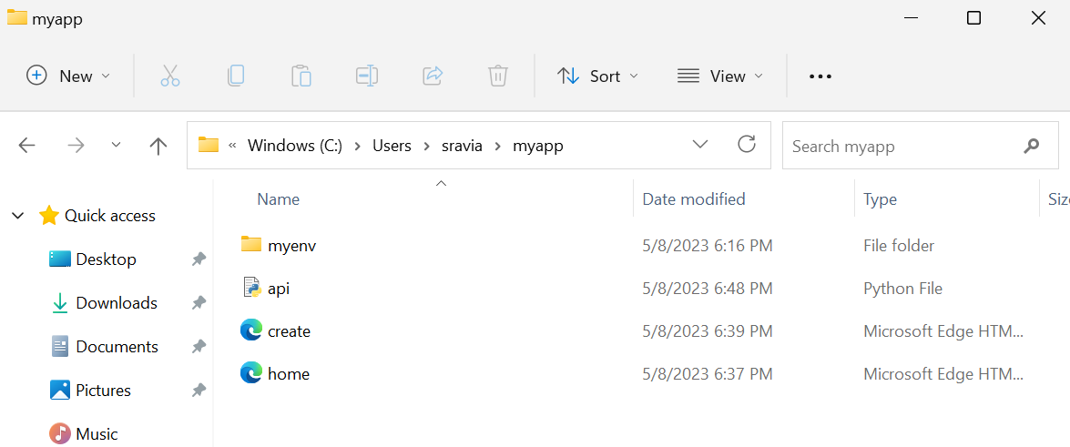
6. Checkout the Python and html files
   1. 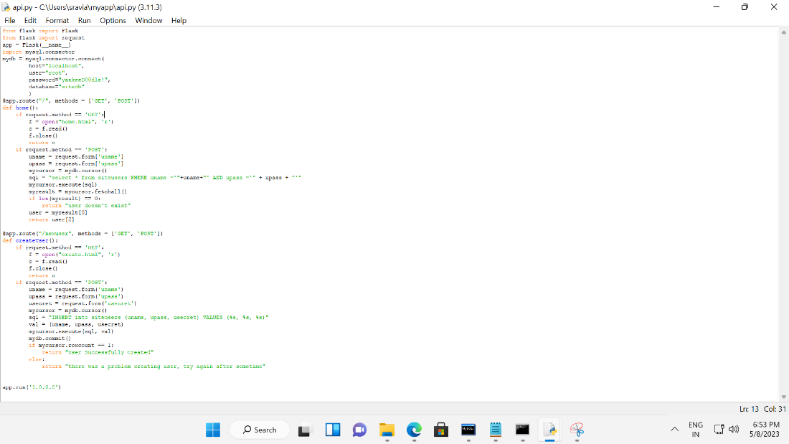
   2. 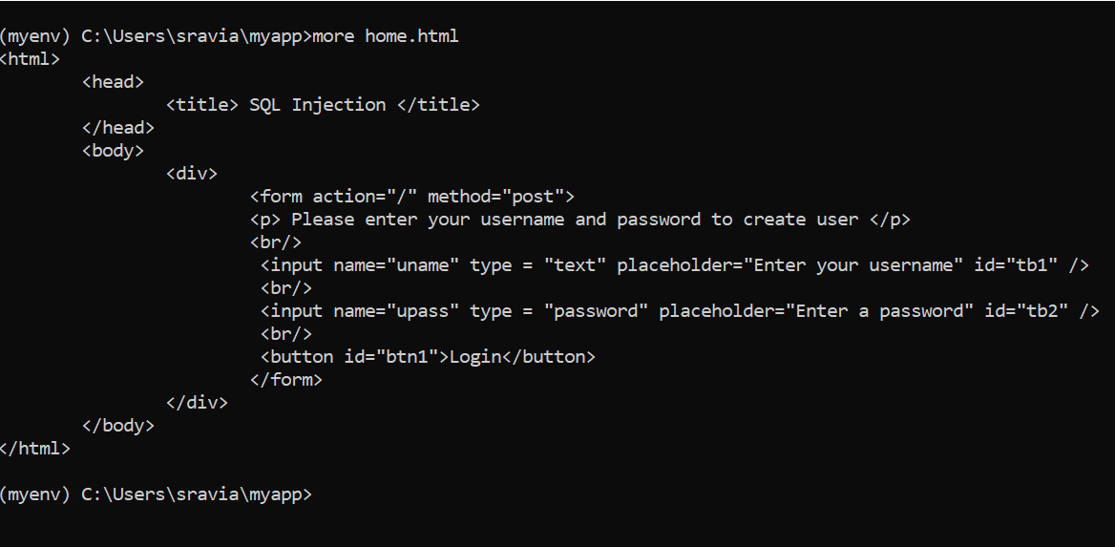
   3. 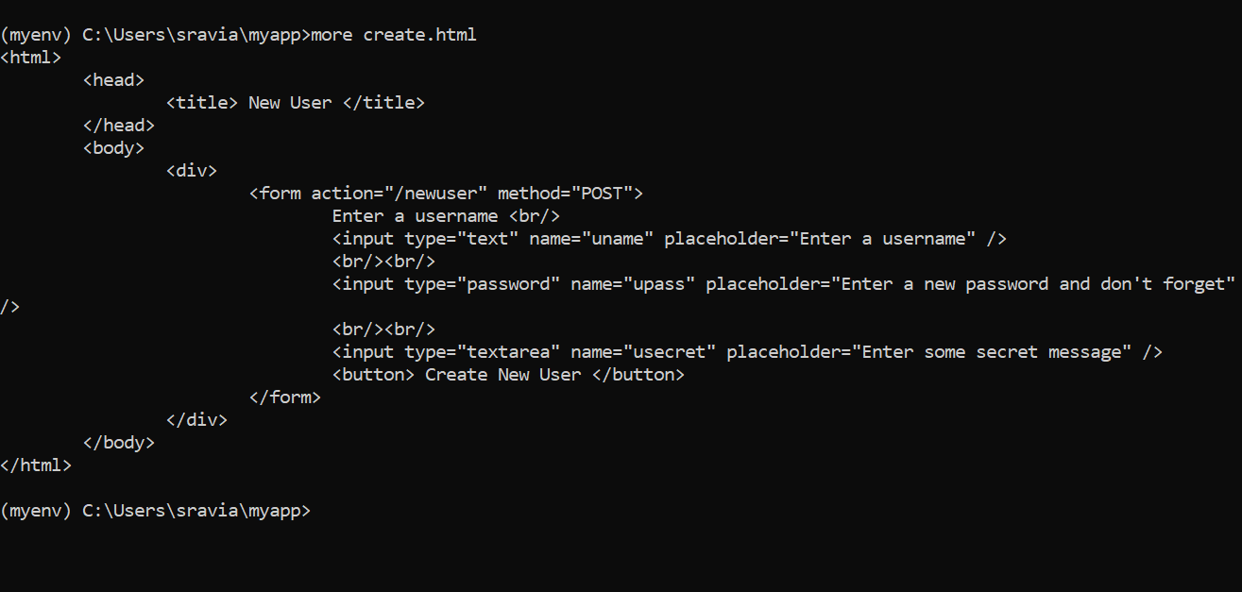
   4. 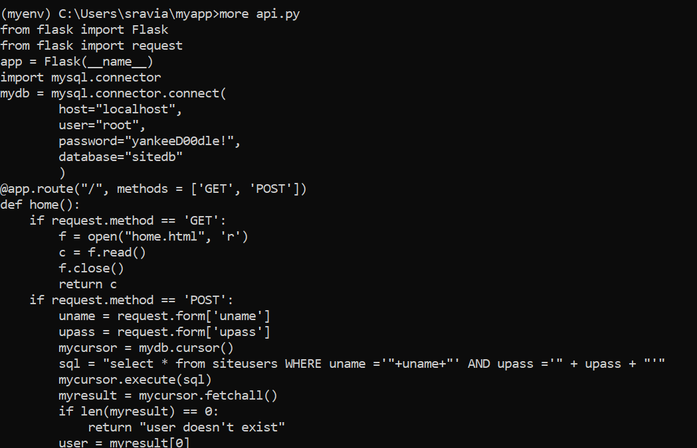
7. Now, let’s try running the app.
   1. 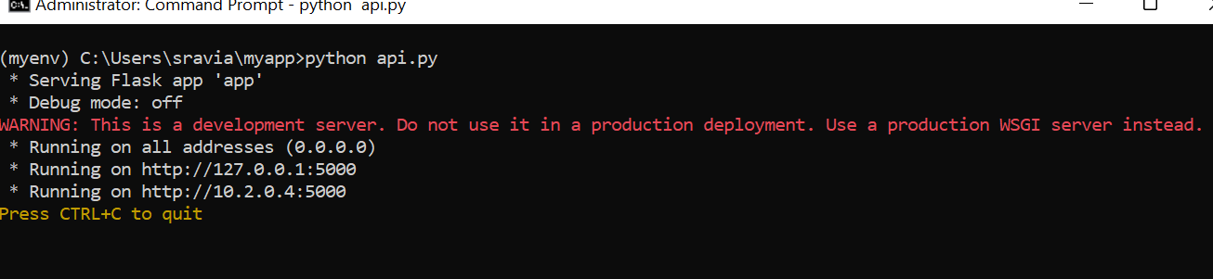
   2. Open a new web browser and navigate to localhost:5000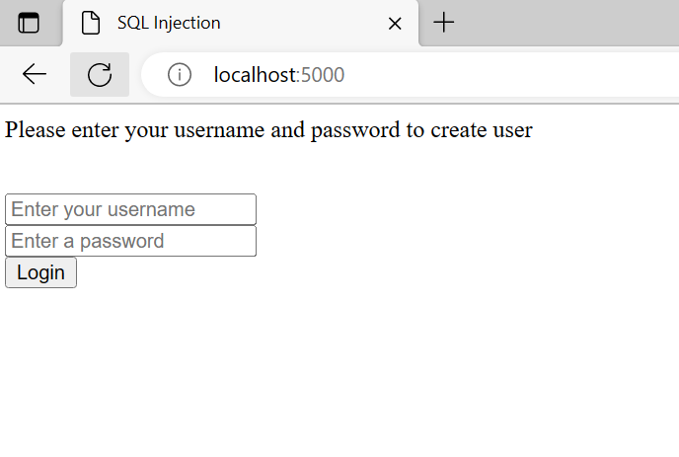
      1. And also to the following URL: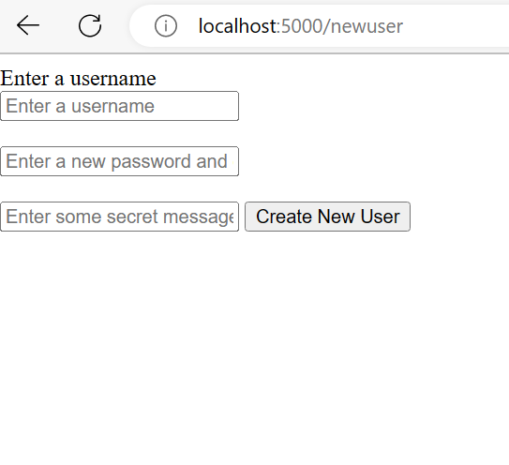
      2. Create a new user as per below screenshot
         1. 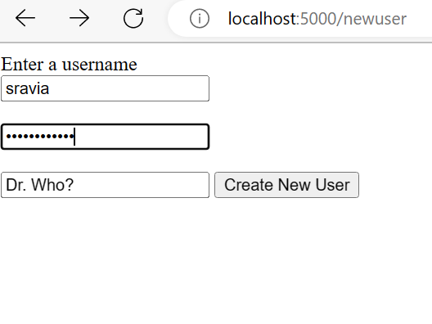

And you are now all set! Congratulations on your starter kit! Build on top of this your own business app!